

A Data Analysis Report On

**ShopNest Store Power BI Capstone**

**Submitted By:**

Jhill Jain

[jhillrj@gmail.com](mailto:jhillrj@gmail.com)

+91 9061047137

# **INTRODUCTION**

ShopNest's commitment to leveraging data analytics to enhance decision-making and operational efficiency is commendable. In the competitive landscape of e-commerce, understanding customer behaviour, market trends, and optimizing supply chain operations can make all the difference. By harnessing data analytics tools and techniques, ShopNest can gain valuable insights into customer preferences, identify emerging market trends, and streamline its operations for better efficiency and cost-effectiveness.

Moreover, in a diverse marketplace like Portugal, where small businesses are a crucial part of the economy, ShopNest's role in connecting them to online channels can significantly boost their visibility and reach. By analysing data related to these small businesses, such as their product offerings, sales performance, and customer feedback, ShopNest can provide tailored support and guidance to help them thrive in the digital marketplace.

In essence, by prioritizing data analytics, ShopNest not only strengthens its own competitive position but also empowers small businesses to succeed in the ever-evolving e-commerce landscape. This strategic approach underscores ShopNest's commitment to innovation, customer satisfaction, and fostering economic growth within Portugal.

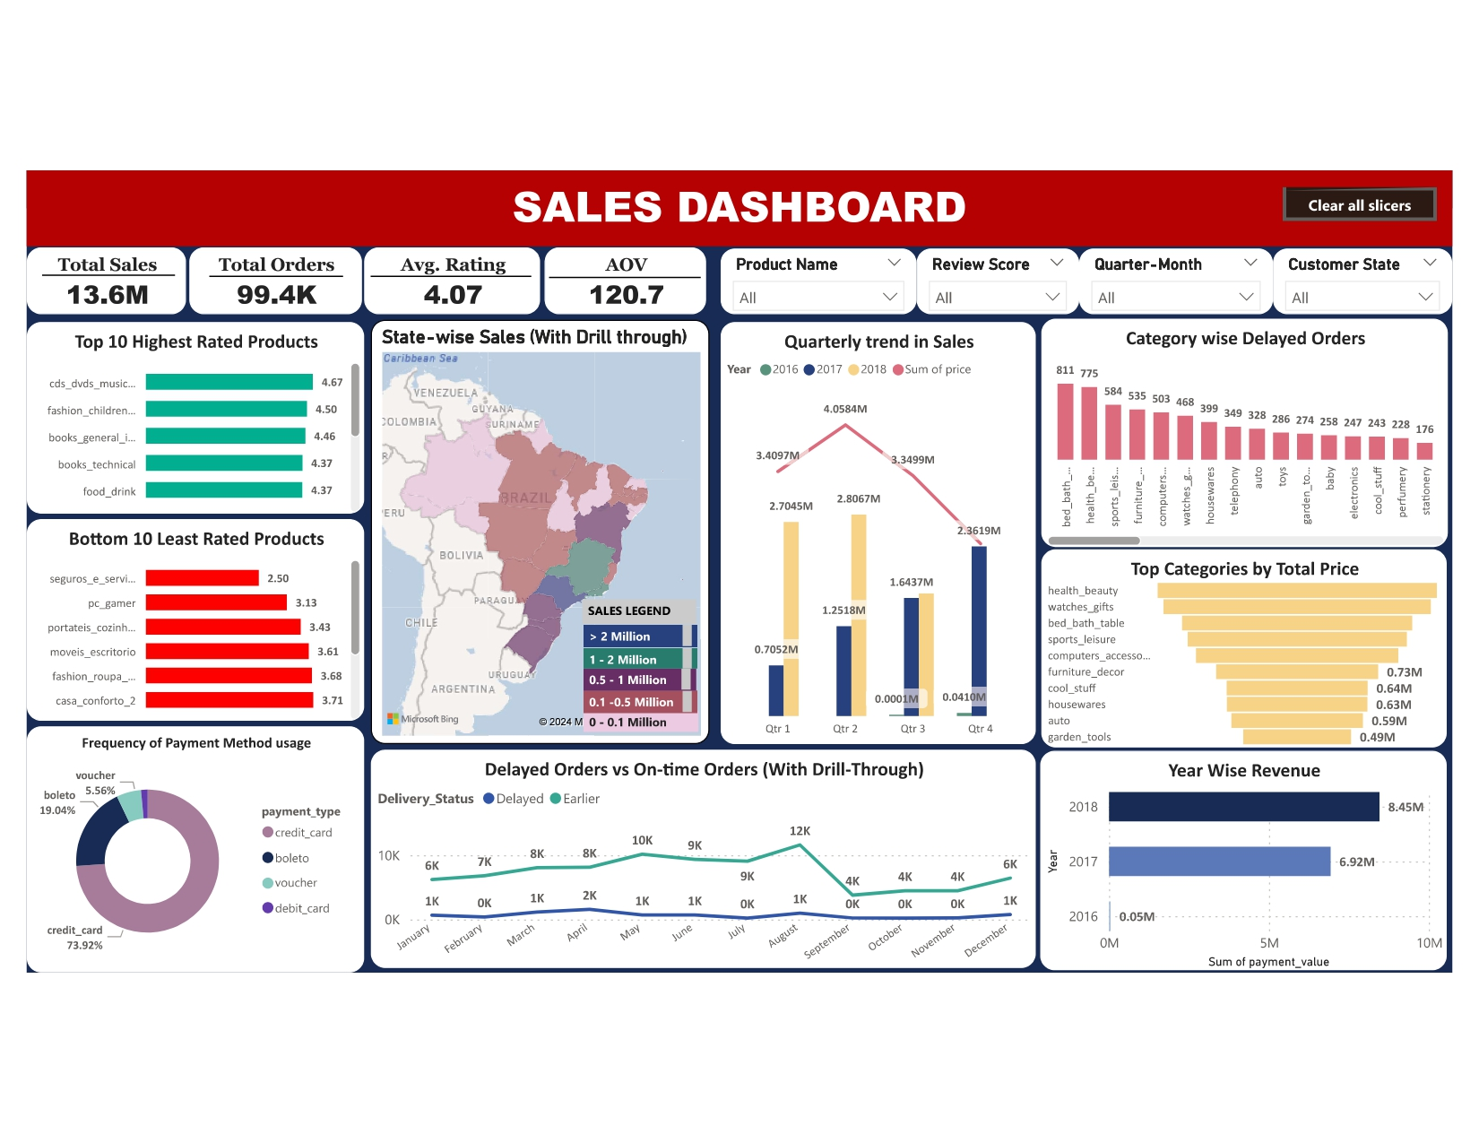**DASHBOARD**

# **TOP CATEGORIES BY TOTAL PRICE**

**Question Statement :**

Identify and visually represent the top 10 product categories by total sales

**Visualization :**

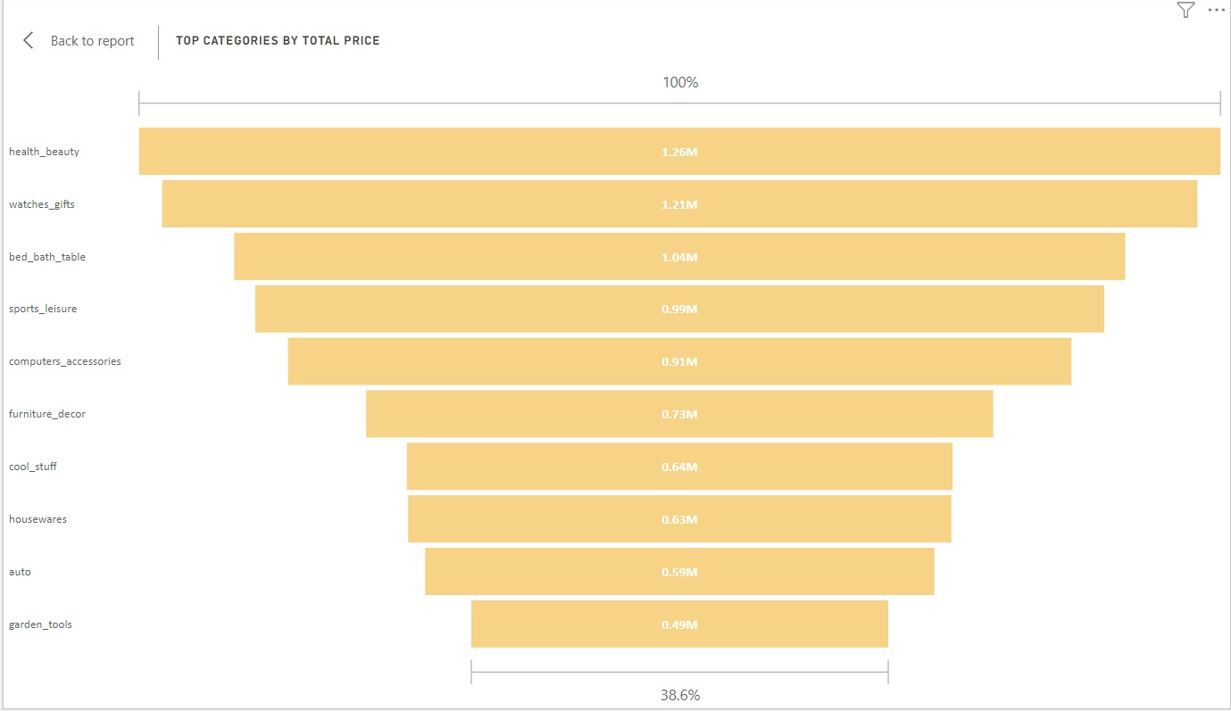

**Explanation :**

The top ten product categories by total sales are shown in the Funnel chart, which provides insightful information about revenue generation. Leading the charge with $1.26 million in sales, Health & Beauty is followed closely by Watches & Gifts ($1.21 million) and Bed, Bath & Table ($1.04 million). Furniture & Decor and Sports & Leisure also have noteworthy results, with sales exceeding $0.9 million. Furthermore, Garden Tools and Auto show commendable $0.49 million and $0.59 million in sales, respectively.

The significance of these best-selling categories is highlighted by this graphic, which offers insightful advice for allocating resources and making strategic decisions to take advantage of customer preferences and optimise revenue potential. These insights into the top-performing product categories provide useful information that can be put to use to boost sales and profitability for businesses. Through the use of this data, companies can enhance their product portfolios, customise marketing initiatives, and cultivate clientele to guarantee long-term commercial prosperity.

# **DELAYED ORDERS ANALYSIS**

**Question Statement :**

Determine the number of delayed orders in each category. An order is considered delayed if the actual delivery date is later than the estimated delivery date.

**Visualization :**

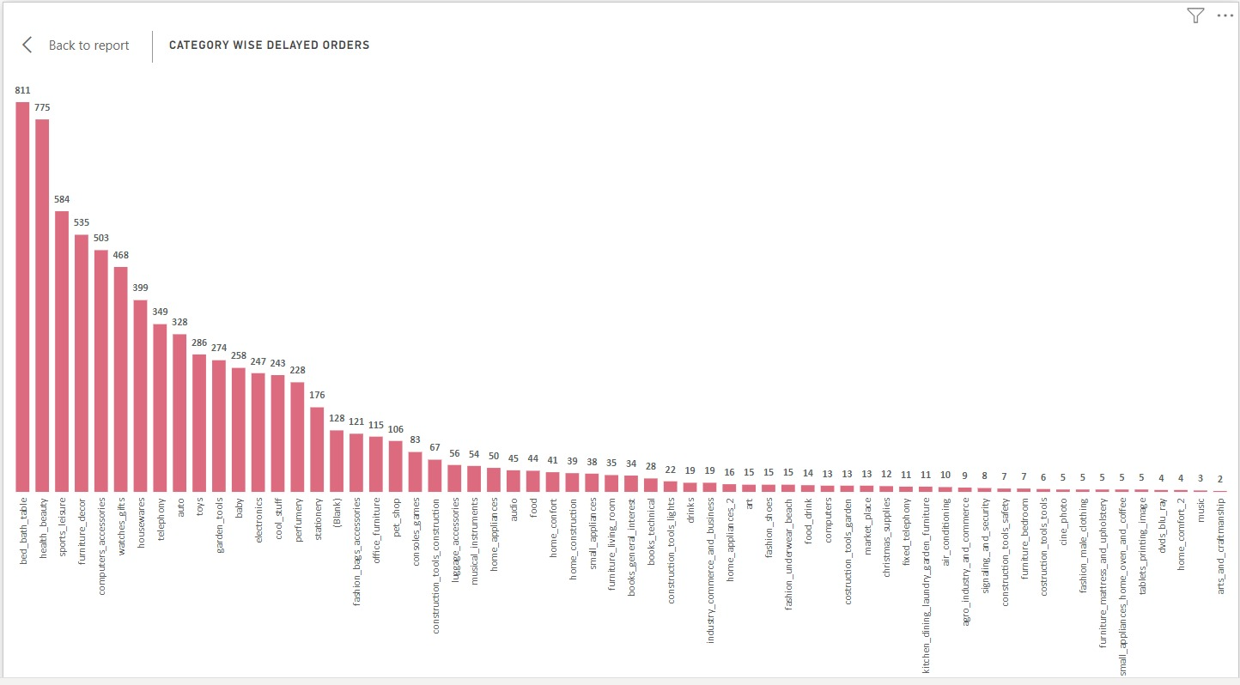

**Explanation :**

Across a broad range of product categories, the bar chart offers a thorough analysis of delayed orders, revealing important information about sales performance and fulfilment effectiveness.

With 811 delayed orders, "Bed bath table" stands out as the category with the greatest number, suggesting possible issues with supply chain management and logistics in this market. Comparably, "Health beauty" and "Sports leisure" show large percentages of delayed orders (775 and 584, respectively), underscoring the necessity of improved coordination and expedited procedures to quickly satisfy client expectations. Additionally, the study indicates notable delays in categories including "Watches gifts" (468 delayed orders), "Computers accessories" (503 delayed orders), and "Furniture decor" (535 delayed orders), indicating systemic problems that need to be addressed right once. On the other hand, product categories such as "Flowers" and "Diapers and hygiene" show relatively few delayed order examples—just one each—highlighting how well these product categories handle and fulfil orders on time.

Additionally, the visualisation helps stakeholders prioritise corrective measures and allocate resources efficiently by facilitating a greater knowledge of the underlying issues driving to delayed orders. Businesses can pinpoint the underlying reasons for delays in order processing, transportation logistics, inventory management, and other areas by analysing patterns and trends across product categories. To manage supply chain bottlenecks and minimise stockouts, for example, categories like "Home appliances" (50 delayed orders) and "Electronics" (247 delayed orders) may need more sophisticated inventory forecasting and replenishment procedures. In the end, the visualisation is an effective tool for promoting initiatives for continuous improvement and a customer-centric approach to corporate operations in the cutthroat world of e-commerce.

# **MONTHLY COMPARISON OF DELAYED AND ON-TIME ORDERS**

**Question Statement :**

Create a dynamic visual that compares the number of delayed orders to the number of orders received earlier for each month. Utilize the drill through cross-report feature to provide a detailed analysis of late and on-time deliveries.

**Visualization :**

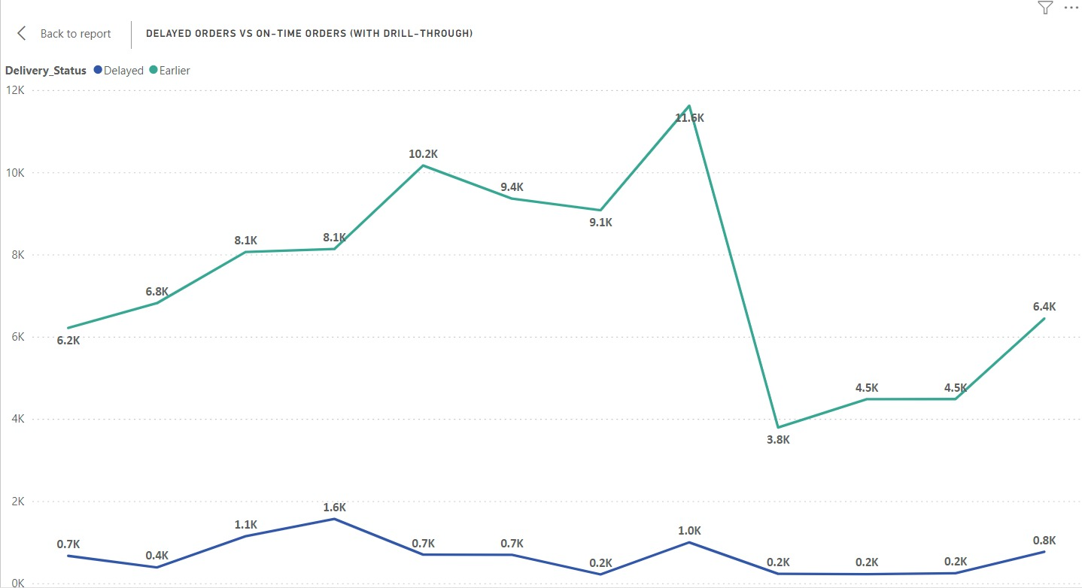

**Drill through:**

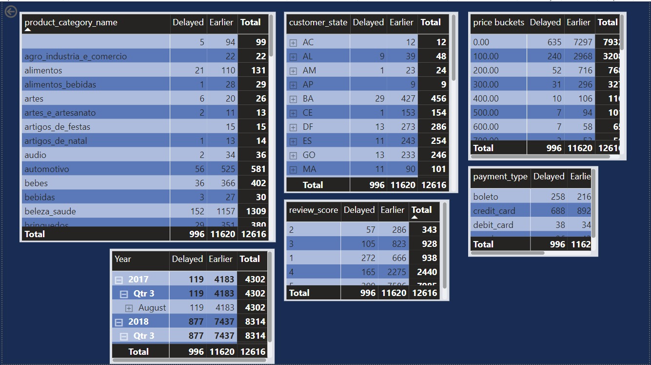

**Explanation :**

A comprehensive comparison of early and delayed orders for every month is shown in the line chart, which gives important information about the year-over-year order fulfilment performance.

With 11,620 earlier orders compared to just 996 delayed orders, August stands out as the month with the biggest difference between delayed and earlier orders. This indicates that August is particularly good at satisfying client requests. On the other hand, July shows the narrowest difference between earlier and delayed orders, with 9,078 earlier orders somewhat exceeding 216 delayed orders. The subsequent months show the same pattern: in September, there were 3,790 earlier orders compared to 231 delayed, in October, there were 4,480 earlier orders compared to 222 delayed, and in November, there were 4,483 earlier orders compared to 245 delayed. These reliable results highlight how well the company performs in quickly completing orders.

There are more delays in December and January (767 and 667 delayed orders, respectively), which may be related to higher client demand over the holidays. On the other hand, June and May have comparatively lower numbers of delayed orders (691 and 696, respectively), which is indicative of effective order processing and logistics management during these times. The organisation may improve customer happiness and loyalty by proactively addressing operational bottlenecks, optimising resource allocation, and implementing targeted tactics to decrease delays by utilising these results.

# **PAYMENT METHOD ANALYSIS**

**Question Statement :**

Analyze the most frequently used payment methods by customers using a visually appealing representation, such as a pie chart or other suitable visuals.

**Visualization :**

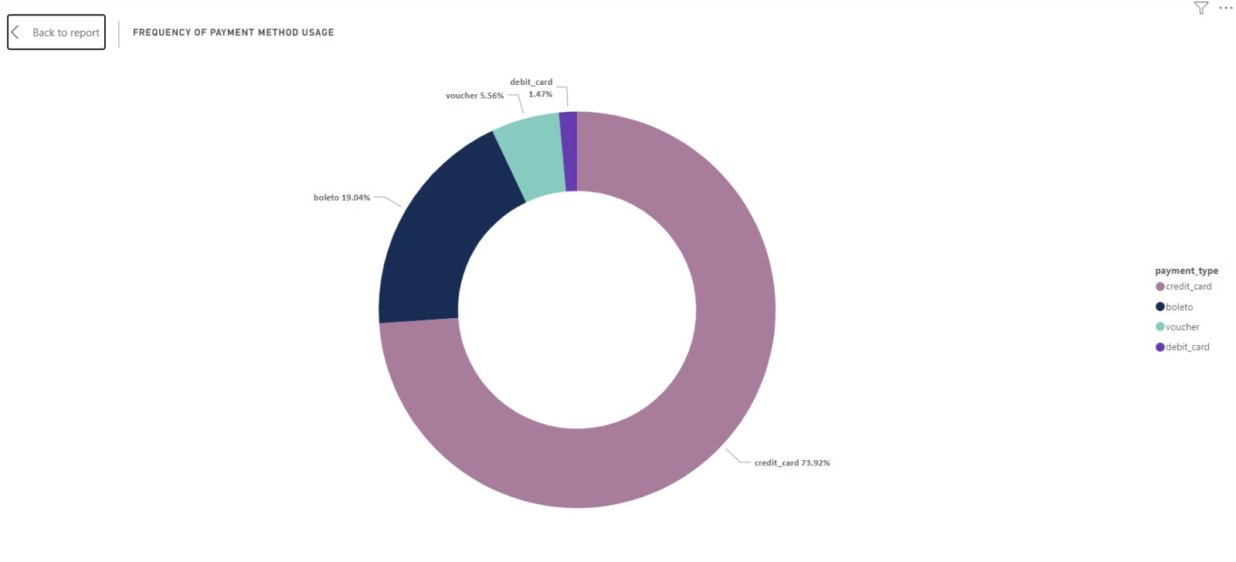

**Explanation :**

The Donut chart provides a clear depiction of payment types and their distribution among customers, offering insights into transaction preferences within ShopNest's e-commerce platform.

Credit card transactions emerge as the most favoured payment method, with the majority of customers, constituting approximately 73.9% of the customer base, opting for this mode of payment. This prevalence indicates a strong preference for the convenience and flexibility offered by credit card transactions.

Following closely, Boleto ranks as the second most preferred payment type, chosen by a significant portion of customers, around 19.0%. The presence of Boleto, voucher, and debit card payments underscores the importance of offering diverse payment options to cater to various customer demographics and preferences.

While credit card transactions dominate, it's crucial to acknowledge the importance of providing alternative payment channels to accommodate diverse customer needs. This diversity not only enhances customer satisfaction but also mitigates the risk associated with relying solely on one payment method.

Furthermore, the visualization serves as a valuable tool for decision-makers to allocate resources efficiently and prioritize payment processing enhancements. Understanding transaction preferences enables ShopNest to optimize payment processing systems, enhance transaction security, and improve overall transaction efficiency to effectively meet evolving customer demands.

# In summary, the donut chart emphasizes the importance of offering diverse payment options while highlighting the dominance of credit card payments within ShopNest's e-commerce ecosystem. This comprehension enables the organization to tailor its payment strategies to better serve its customer base and foster sustained growth in the competitive e-commerce landscape.

# **PRODUCT RATING ANALYSIS**

**Question Statement :**

Determine the top 10 highest-rated products and the bottom 10 lowest-rated products using a bar or column chart.

**Visualization :**

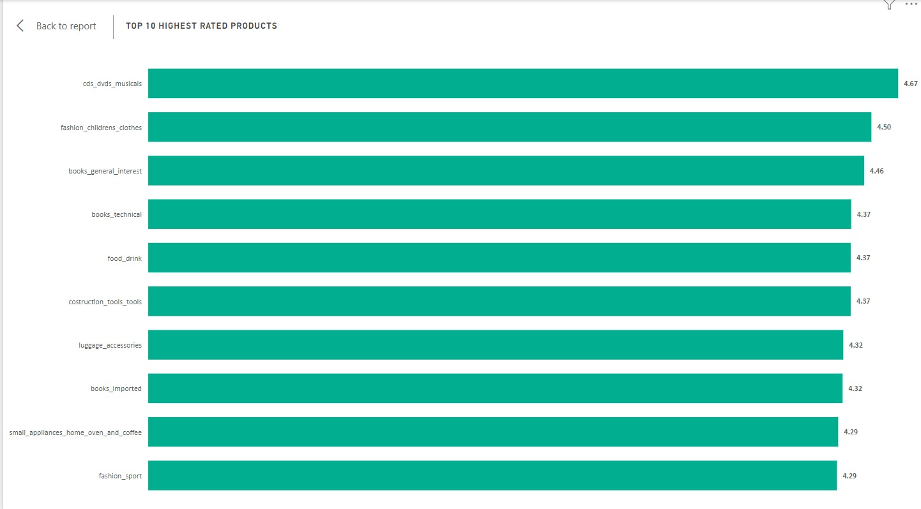

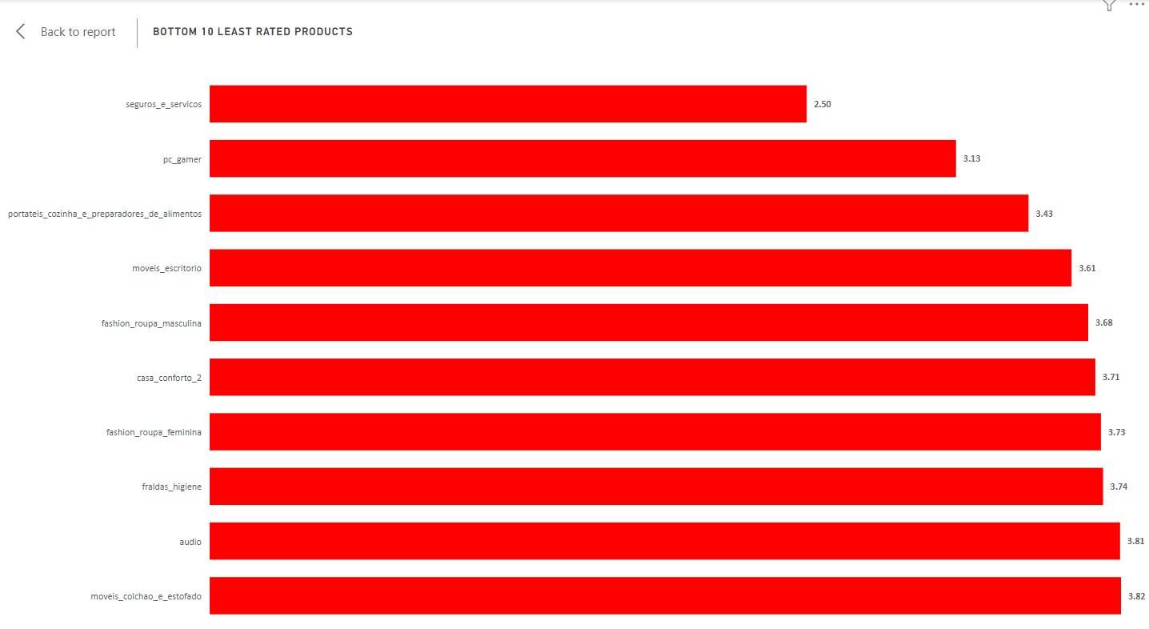

**Explanation :**

Based on average customer ratings, the bar chart presents a succinct summary of the top 10 product categories. It offers insightful information on customer preferences and satisfaction levels inside ShopNest's e-commerce platform.

With a remarkable average rating of 4.67, "CDs, DVDs, and Musicals" tops the list and demonstrates the highest level of consumer satisfaction in this area. With average ratings of 4.50 and 4.46, respectively, "Fashion Children's Clothes" and "Books General Interest" come in second and third, demonstrating the popularity and excellent quality of these products with consumers.

Additionally, the average ratings for "Books Technical," "Food & Drink," and "Construction Tools & Tools" are comparable at 4.37, highlighting the consistent level of customer satisfaction across a variety of product categories. Interestingly, "Fashion Sport" and "Small Appliances Home Oven and Coffee" also receive excellent average ratings of 4.29, indicating very positive feedback from customers in these categories.

The graphic highlights how crucial customer satisfaction and product quality are in fostering general happiness and loyalty. It provides information about particular product categories that are frequently rated highly, which is helpful advice for making strategic decisions and directing efforts related to product development.

The demand for upscale and specialised products is indicated by the inclusion of "Books Imported" and "Luggage Accessories" in the top 10 highest-rated products, while the popularity of "Fashion Children's Clothes" and "Fashion Sport" highlights the importance of style and functionality in customer preferences.

All things considered, companies may use bar charts to better understand consumer sentiment, improve product offers, and determine which expenditures to make in order to increase overall customer happiness and promote long-term business growth in ShopNest's e-commerce marketplace.

# **STATE-WISE SALES ANALYSIS**

**Question Statement :**

Identify and visually represent states with high and low sales, providing a clear understanding of regional sales performance.

**Visualization :**

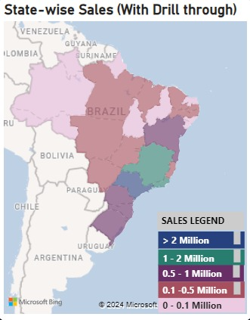

**Drill Through:**

Sales made by each state

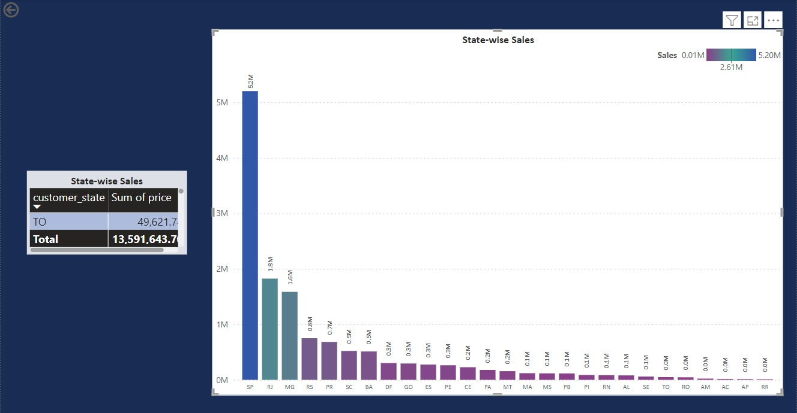

**Explanation :**

The map graphic provides a thorough analysis of sales performance in different states inside ShopNest's online store, highlighting significant variations in income production. Out of all the states, São Paulo (SP) is the best-performing, with sales above $5.20 million, or 38.3% of total sales. Rio de Janeiro (RJ), which brings in about $1.82 million and accounts for 13.4% of total revenue, comes in just behind.

Additionally, sales data for Minas Gerais (MG) and Rio Grande do Sul (RS) are noteworthy, with around $1.59 million and $0.75 million in revenue, respectively, accounting for 11.7% and 5.5% of overall sales. On the other hand, states such as Roraima (RR) and Amapá (AP) demonstrate lower sales statistics that fall into the lowest sales bracket. Roraima's sales are $0.007 million, while Amapá's sales are $0.013 million. Both states contribute less than 0.1% to the total income.

States with different sales values are shown gradientally in the map chart, which sheds light on regional sales trends. It emphasises how important states like Rio de Janeiro and São Paulo dominate the total sales performance and points out areas with lower sales figures that have room to expand.

The graphic also highlights how crucial resource allocation and strategic planning are to maximising sales potential across various geographies. Although São Paulo and Rio de Janeiro command substantial market shares, states such as Roraima and Amapá provide unexplored avenues for growth. In order to maximise sales performance and promote sustainable business growth across a range of geographic regions, this study provides decision-makers with insightful knowledge of regional sales trends, which in turn guides strategic planning and operational decisions.

# **SEASONAL SALES PATTERN**

**Question Statement :**

Investigate and visualize any seasonal patterns(Quarterly) or trends in sales data over the course of the year.

**Visualization :**

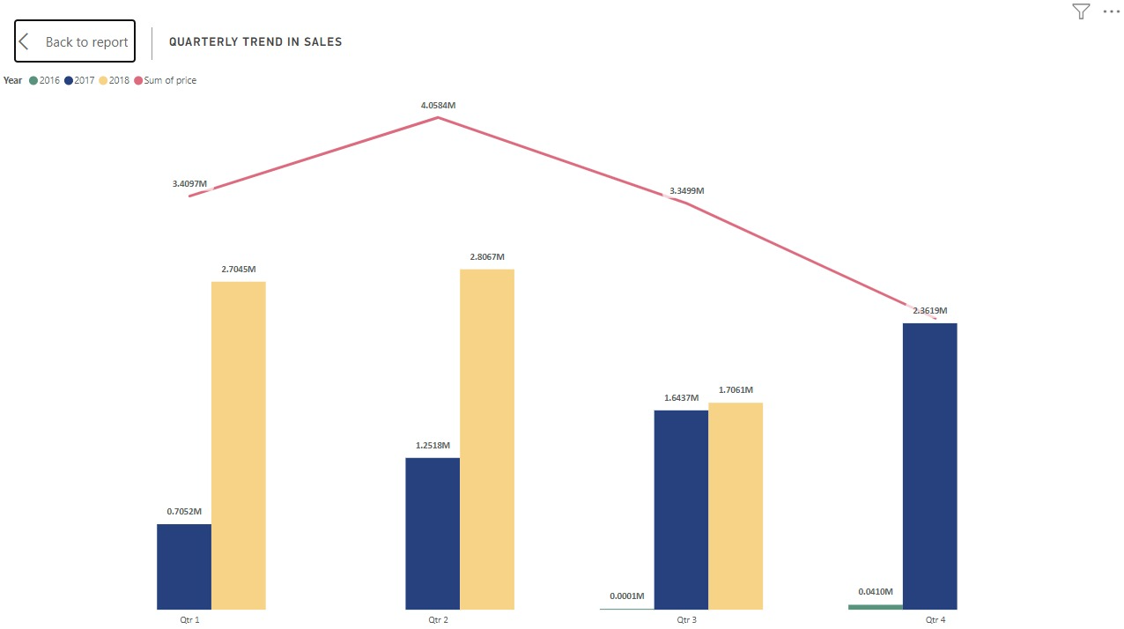

**Explanation :**

Offering a thorough overview of quarterly sales performance over several years, the combo chart provides insightful information on the dynamics of sales trends and seasonal fluctuations within ShopNest's e-commerce platform.

The sales numbers for every quarter across multiple years are presented as bar charts, which highlight different trends. Remarkably, revenues exhibit a consistent rising trend in every quarter, with perceptible variations throughout years. For example, revenues increased significantly year over year from $0.71 million in the first quarter of 2017 to $2.7 million in the same period of 2018. Comparably, the amount spent in the second quarter of 2018 increased from $1.25 million in 2017 to $2.81 million, indicating ongoing growth and consumer demand.

In addition to this analysis, the line chart provides a comprehensive viewpoint by showing the total sales for each quarter, making it possible to spot broad trends and patterns in the increase of sales over time.

Additionally, the combination chart emphasises how sales are seasonal, showing clear variations across quarters. Remarkably, sales hit $4.1 million in the second quarter, which is normally the highest period; first-quarter sales reach $3.4 million and third-quarter sales reach $3.3 million. This highlights how important it is to use resources strategically in order to take advantage of moments of high consumer spending while maintaining steady performance all year long.

To sum up, the combination chart offers insightful information about seasonality and sales trends, enabling companies to plan ahead and maximise their sales tactics for long-term success in ShopNest's e-commerce ecosystem.

# **REVENUE ANALYSIS**

**Question Statement :**

Determine the total revenue generated by ShopNest Store  and analyze how it changes over time(Yearly). Represent this information through suitable visuals to highlight trends and patterns.

**Visualization :**

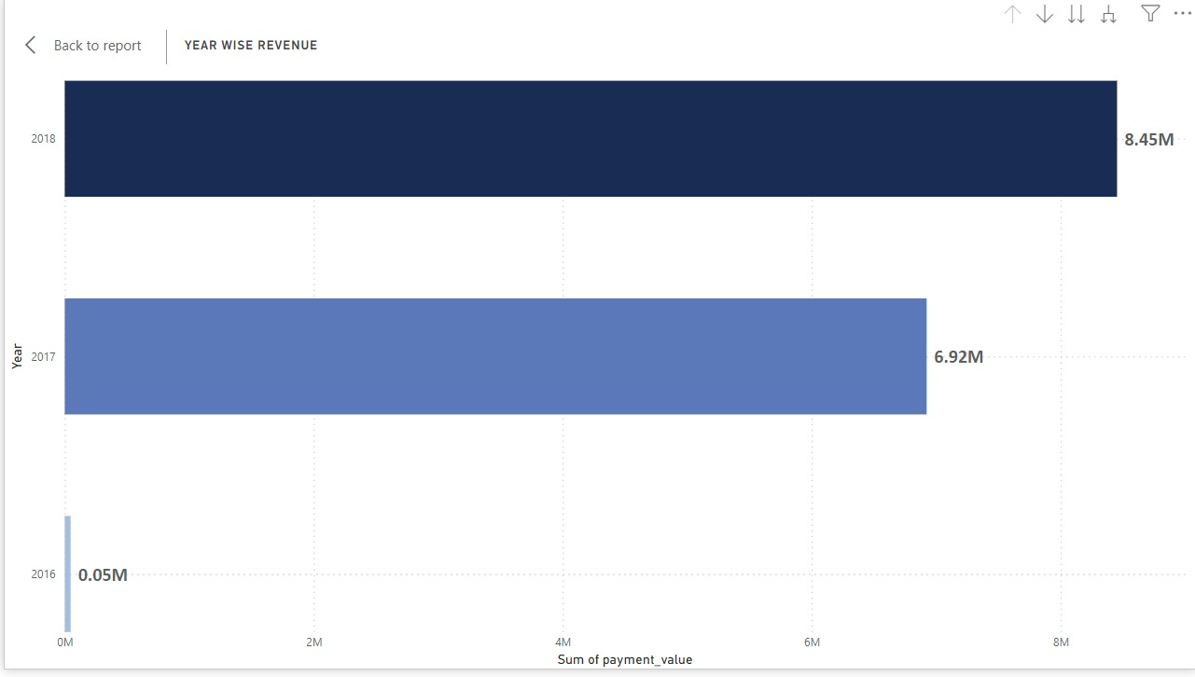

**Explanation :**

A bar chart provides a visual representation of revenue trends across time, allowing for meaningful observations on revenue performance trends.

Notably, there was a notable spike in sales from 2016 to 2017, rising from a meagre $47k in 2016 to a staggering $6.92 million in 2017. This significant growth trajectory highlights favourable market conditions and the success of company initiatives that were put into place during that time.

Additionally, the graph shows a steady increase in sales, which culminated in a noteworthy peak of $8.45 million in 2018. This points to steady expansion and ongoing success in generating income. The noteworthy rise observed between 2017 and 2018 underscores the organization's flexibility in capitalising on prospects and adjusting to changing market circumstances, ultimately resulting in strong financial outcomes.

# **CONCLUSION**

**Key Insights and Recommendations:**

**1) Regional Sales Performance:** It is evident from a review of state-level sales data that some areas, like Rio de Janeiro and São Paulo, contribute significantly to total revenue generation. Sales performance can be further improved by focusing on important markets and looking into growth potential in areas with lower sales figures.

**2) Fulfilment Efficiency:** By exposing possible issues with supply chain management and logistics, delayed order analysis offers insights into fulfilment efficiency. Order fulfilment and customer satisfaction can be raised through process optimisation and systemic issue resolution.   
 **3) Seasonal Sales Trends:** Variations in seasonal sales over the course of several quarters highlight the significance of strategic planning to take advantage of peak customer spending times. Businesses can successfully manage resources and customise sales strategies for long-term growth by having a thorough understanding of seasonal fluctuations.

**4) Preferences for Payment Methods:** The majority of customers use credit cards, demonstrating a preference for ease and flexibility. In addition to satisfying a range of consumer preferences, providing many payment alternatives improves transaction efficiency.   
 **5) Product Satisfaction:** Product ratings study highlights how important customer experience and product quality are in fostering loyalty and satisfaction. Businesses can enhance customer happiness by improving their offerings and prioritising investments by leveraging data from top-rated items.

**6) Revenue Growth and Trends**: Examining revenue trends over a period of time reveals notable growth patterns that are indicative of advantageous market conditions and successful business tactics. Consistent revenue increase indicates the organization's adaptability and capacity to grasp chances for sustained prosperity.   
 **7) Strategic Implications:** The knowledge gained from these analyses provides insightful advice for allocating resources, making strategic decisions, and enhancing operational efficiency. In the cutthroat world of e-commerce, agencies can achieve sustainable business growth and profitability by optimising sales strategies, streamlining procedures, and utilising actionable analytics.

In conclusion, having a thorough grasp of revenue trends, client preferences, fulfilment effectiveness, and sales performance enables companies to develop focused plans and make well-informed decisions that will give them a competitive edge in the ever-changing e-commerce market.